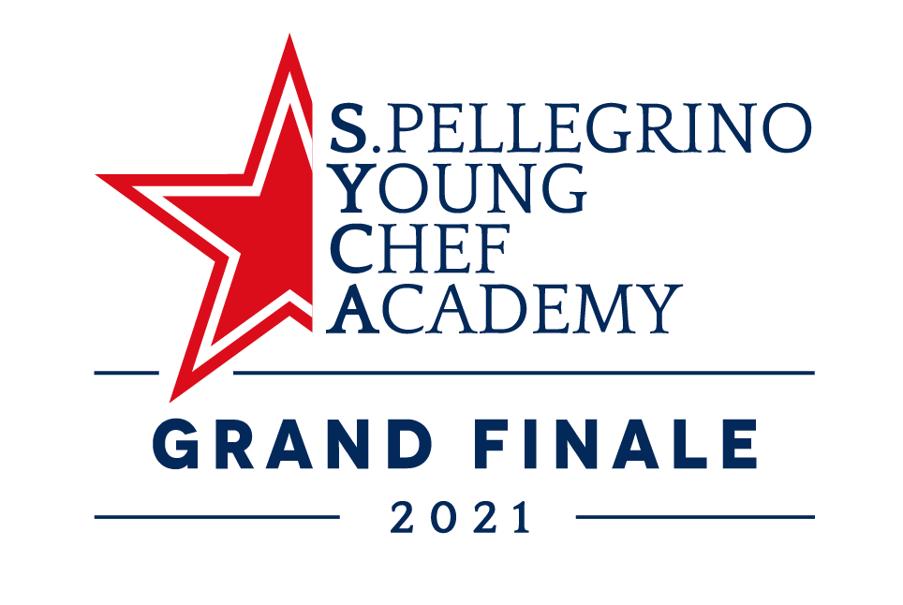
THE GRAND FINALE OF S.PELLEGRINO YOUNG CHEF ACADEMY COMPETITION 2019-21
WILL HOST FOR THE FIRST TIME
THE S.PELLEGRINO YOUNG CHEF ACADEMY “BRAIN FOOD” FORUM

An inspiring exchange of knowledge and ideas between young chefs and some of the greatest chefs in the world, curated by Fine Dining Lovers, will enrich the exciting program
of the three days event in Milan.

22 October 2021 – S.Pellegrino Young Chef Academy is proud to announce the first edition of the S.Pellegrino Young Chef Academy “Brain Food” Forum that will be held on 30th October, at the Grand Finale of the S.Pellegrino Young Chef Academy Competition 2019-2021 in Milan, and is curated by Fine Dining Lovers.

The launch edition of the Forum, with Fine Dining Lovers’ editor-in-chief Ryan King as host, will focus on Taste & Creativity and will inspire all the young chefs and real food enthusiasts who attend the event, providing stimulating ideas and reflections related to the world of gastronomy.

The forum line-up will include the likes of Massimo Bottura and Virgilio Martinez who will discuss the key themes, demonstrating how creativity, drive for taste, and discovery do not just result in delicious food, but can also change lives for the better. Bottura will discuss his mission to save food from waste, his appointment with the UN Environment Program (UNEP) as Goodwill Ambassador, and Refettorio projects – cultural community hubs with social kitchens under the vision of the nonprofit Food for Soul now partnering with the S.Pellegrino Young Chef Academy – mobilizing and empowering local communities to reduce food loss and waste and support social inclusion. Martinez will talk about his project ‘Mater’, undertaken to catalogue and rediscover ingredients and techniques within the local communities of the Andes and the Amazon to preserve indigenous gastronomic culture for the future.

In addition to Bottura and Martinez, the forum will host seven additional leading figures in global gastronomy who will also be the members of the Grand Jury who will decide the winner of the S.Pellegrino Young Chef Academy 2019-2021 Award: Enrico Bartolini (three-star Michelin chef originally from Tuscany is one of Italy’s, and the world’s, brightest gastronomic talents), Manu Buffara (executive chef and owner of Manu in Curitiba, which is paving the way for gastronomy in Brazil), Andreas Caminada (at the age of only 33, he earned three Michelin stars, and today showcases his vision of gastronomy in the historic 13th-century castle of Schauenstein, Switzerland), Mauro Colagreco (Italian-Argentine chef at the three-Michelin-star restaurant Mirazur in Menton, France), Gavin Kaysen (James Beard Award winner and one of the founding mentors of the non-profit Mentor BKB Foundation (formerly Bocuse d’Or USA Foundation), Clare Smyth (the first and only female chef to run a restaurant with three Michelin stars in the UK) and Pim Techamuanvivit (owner of Nari, Kamin, and Michelin-starred Kin Khao in San Francisco, and the executive chef of Michelin-starred Nahm in Bangkok). These Seven Sages will make up a panel of experts that will invite questions and discussion around the themes of Taste & Creativity. Young talents and previous winners of the S.Pellegrino Young Chef competition, Mitch Lienhard (USA, 2016) and Mark Moriarty (UK & Ireland region, 2015) will also be in attendance to discuss expectations of young chefs today and their experiences in the industry.

The topics of Taste & Creativity are chosen to reiterate the core values of the S.Pellegrino Young Chef Academy: an online educational platform created to attract, connect and nurture diverse talent in the world of gastronomy.

Following the launch event, the S.Pellegrino Young Chef Academy “Brain Food” Forum will continue to take place at various locations across the globe, offering insight across varying themes with the aim of providing direct access to knowledge from global figures in the hospitality industry.

The Brain Food Forum will be available to view via live stream on Fine Dining Lovers, after registration to FDL+, on Saturday 30th October from 09:30am-12.30pm CET.

The S.Pellegrino Young Chef Academy “Brain Food” Forum isn’t the only novelty of this year competition: on 29 October, Michelin-starred chef Cristina Bowerman will meet the young female chefs attending the event for an informal chat on Women's Leadership, sharing with them her international experience as a successful chef, entrepreneuse, consultant and coach. This meeting will be the first activity of a long-term empowerment programme from the S.Pellegrino Young Chef Academy intended to nurture the next generation of young female professionals.

- ENDS -

About S.Pellegrino and Acqua Panna
S.Pellegrino, Acqua Panna and Sanpellegrino Italian Sparkling Drinks are international trademarks of Sanpellegrino S.p.A., which is based in Milan, Italy. Distributed in over 150 countries through branches and distributors on all five continents, these products represent quality excellence by virtue of their origins and perfectly interpret Italian style worldwide as a synthesis of pleasure, health and well-being. Founded in 1899, Sanpellegrino S.p.A. is the leading company in the beverage sector in Italy with its range of mineral waters, non-alcoholic aperitifs, drinks and iced teas. As a major Italian producer of mineral water, it has always been committed to enhancing this primary good for the planet and works responsibly and passionately to ensure that this resource has a secure future.

About Fine Dining Lovers
Fine Dining Lovers is an international digital platform that publishes insider information from within the restaurant world, drawing on its unique access to the best the industry has to offer. The online magazine is supported by S.Pellegrino and Acqua Panna, but is editorially independent.

For more information:
(Local agency name)
Enter your respective contact info here.

Sanpellegrino S.p.A.
Barbara D’Amico - Barbara.DAmico@waters.nestle.com
We Are Social
Sabrina Varaldo - sabrina.varaldo@wearesocial.net

